

School of Computing and Mathematics

PRCO303

Final Stage Computing Project

INTERIM Report 2

BSc (Hons) Software Engineering

J. P. R. Chamuditha Jayaweera

Food Tracker

Supervisor: Mr. Iman Ashley

2020/2021

Table of Contents

1. Introduction 3

2. Business Case 4

2.1 Business Need 4

2.2 Business Objectives 4

3. Project Objectives 5

4. High-level diagram 9

5. Task undertaken and outcomes 13

6. Products produced and product quality 14

6.1 Login 14

6.2 User Signup 14

6.3 Forgot Password 15

6.4 Main menu 15

6.5 Add Items 16

6.5.1 OCR Method 16

6.5.2 Manual Method 18

6.6 View Items 18

6.7 Edit item 19

7. Test Case 20

7.1 Data Insertion using OCR in mobile application 20

8. Risks that have materialized and your responses, changes to the risk list 21

9. Schedule 22

9.1 Project Plan 22

10. Resources 23

11. Learning undertaken and Required 24

Appendices 25

References 25

Proposal 25

PID 28

Meeting minutes 35

# Introduction

Food is thing that if one can get and other cannot afford it. Some can get more food and other can’t have much. Most of the peoples are busy these days. They are not much care about the things other than themselves. So, people have forgot that little things that can be a huge problem as an example we can take food waste. Which can define as foods that discarded by the consumers. If we simply go through that we can refer food waste as, the foods or foods product that buy from market and discard or throw away without consume. That is not much big problem for the one single human, but it will be uncontrollable environmental matter which cause by the environment pollution. How can be that environment pollutions occur? It is caused by food wastages that we throw away fills with greenhouse gas also known as methene. And un-reclaimed phosphorus in the food leads further mining. This food waste can also be a reason for environmental effect on agriculture, by reducing the total amount of water, land, and other resources.

In the other hand food is basic need of a life. But there are countries which are suffer from the famine. One country’s people waste foods and some other country’s peoples are dying for not having enough foods for consumption. one in nine people do not have enough food to take, that’s 793 million people who are undernourished. if we manage it correctly, we can fair to all the people living around the world. When we are talking about the food wastage in numbers one third of all food produced is lost or wasted. Around 1.3 billion tonnes of food, costing the global economy close to $940 billion each year. The 10% of the greenhouse gases are come from the foods that is produced, but not eaten. If food waste was a country, it would be the third biggest greenhouse gas emitter after the United State of America and China. In those greenhouse gases which mainly contain methane, are 28x stronger than carbon dioxide.

As mentioned above we can help to protect our environment that cause a huge global problem by following simple rules. In the last two years’ time people are changed with pandemic situation and move on with new technologies. So how can be this revolution can change the food wastage. Most people are busy with their day-to-day life activities, work or education, family, or various activities. but the people never refuse to go through their mobile phones, laptop or any smart devices. Even they have a very busy lifestyle they spend at least small amount of time with their mobiles. Some people used smart devices just for browsing social media or internet and some of them are used to do their daily work. So, without wasting a time on social media how we can referral people to save the earth. We could get the biggest chance having the pandemic, which is now the people love to be using the technology other than the manual or old systems or methods.

Nowadays most of the shops/supermarkets are introduced their own brand mobile applications. Or they are selling products through the online food ordering companies and online web sites. So, there are lots or customers are using these facilities through their smart devices. and for those people can use mobile application which remainder if the customer’s bought foods are going to expire. And, by without wasting those foods, can use as an ingredient to make different foods. In these days, people are more care about foods calories and the energy amount contained in the foods. So, from this application user or customer will be able to get information of the calorie in their foods. They can get different food recipe according to the foods, that they owned according to the energy’s foods have. When these mobile application users are raising the amount of foods, that can be save without waste also raise. Personally, mobile application can be an advantage in many ways. It can help user’s health, financial, and creativity. From this mobile application can focus the users to make different kinds of food according to the different recipes. It can help to enhance the user’s creativity. Otherwise, when we manage our foods without wasting and get maximum use of foods it saves the money.

As a summary Food tracker is an application for most of the people who are struggling to manage the foods. It not only the mobile application for food management. It can analyse and suggest food items to users. And users can get a report of their consumption and wastages, based on their purchased food items. This project contains a system for the shopping markets. Its basically having the loyalty system, which they can track their customers purchased items. This solution will be a better answer for the huge amount of food wastage and environment pollution.

# Business Case

## 2.1 Business Need

In these days, people are busier with different matters. People does not pay special attention to their foods. And they do not have much care about the food they bought from the supermarket or shops or specially their expire dates. Nowadays people used eats junk foods or instant foods. Other than that, foods some are used to be healthy. So, they are only consuming healthy food products. But use of that healthy products they have to pay attention on their quality. So, when talk about the food quality, it is dependent on the foods expire date. But with this restless busy lifestyle they cannot give separate attention for that kind of information. Therefore, if the food products are expired, they cannot consumption. we can take it as a food wastage.

Fact, people are more familiar with mobile phones rather than the few years ago. By taking that as an advantage we can use mobile devices to give an update to the people about their foods.

So, from the mobile application user get notifications whenever the foods getting near to expire. Not only notification but also user can view different types of reports that analysed from the food item purchases from the stores. So, with these features we can save certain amounts of foods and money from wasting.

## 2.2 Business Objectives

As business objectives there are few main points to consider when developing this solution. Basically, this project is based on the “How to reduce food wastage”. It is huge problem rise all around the global. Food wastage can mainly affect the environment pollution and can be threatened to the many living species including the humans. So other than that matter, there are hundreds of thousands, or millions of people are dying because of the hunger and malnutrition. This solution can take as a first step to avoid this crisis by managing foods correctly in our own home. For archive this milestone, we can name some of our business objectives as below,

* To save the foods without wasting and give better understanding about food wastage.
* Reduced the amount of money that waste from food waste.
* Remind the users if the foods that are not consumed, are going to expire.
* Acknowledge the users how much spent on their food items.
* Manage the foods items accordingly.

# Project Objectives

On this project there are few main project objectives should have to consider. Other than that, this project is about a solution for food wastage. Then we have to consider what must be done for the archive main objective of this project. Below are some main objective points, will have to consider when developing this solution.

1. To analyze the foods or the products which are wasting with weather conditions.

When considering food wastage, all the food products wastage are not same. They are different in different reason, such as dried foods or the grains are last longer than the vegetables or fruits. And when talk about food packing, people cannot store some foods in refrigerator. Or otherwise, cannot store in a direct sunlight. That will directly affect the food product quality. So, it can have shorter time period to expire than the expected. Which means there may be an unexpected change due to the natural causes. As a good productive project solution, it has to analyze what type of foods that can be waste without knowing the user. When we take an example, Fruits are ripe quickly normally the customers are may consumed it, but if the customer does not consume and keep it refrigerator it may can keep fresh for several days, but if the customer does not keep that same item in refrigerator, it may be turn into food waste. So, in that case when developing the solution need to find out which product can be waste more quickly with various environmental conditions. As an example, when customer brought an apple from the market and if he/she decide to store in refrigerator it will keep fresh or keep it without wasting it for several days other than the leave it in outside.

As a project objective I have to identify what are the solution when customers add these kind of food products to their product list. It is an uncontrollable issue that have to face when developing this project. Because from this solution cannot control how the user’s store food item in their place. Therefore, this type of issues I have go through the all the kinds of food items that will affect environment factors and give an average time period for each of the food item.

1. To analyze and figure it out how the shops/supermarkets databases save the information’s of the products.

In the large-scale supermarket, they are having a huge range of products in different categories. Also, they maintain loyalty membership which track their customers purchases and used analyze their sales. When we take an example in the fruit category their may be apple and that can be categorize into different types. And for each type they valued different prices. Likewise, there may be complex and unique database system owned by large supermarket or shops. When we take a single grocery store, they may only have the basic point of sales system. For that kind of issue, we have to install this project solution’s point of sales system to maintain loyalty customers database. Or otherwise, customers can use their mobile device and add each product by themselves. And those stored data have to use for the analyzing. Those analyzed data can be used for both customers and the shop owners. So the solution database should be created to help the analyzing part as well.

As a summery, in this solution also have to figure it out how they manage to store data in efficient way and what are the areas they area collecting the data about. Because if we take on food category, there might be hundreds of types of foods in a single category. So, it has to be done in very efficient way. For this solution, it has to find out the expire date of each product. But it can be different with same type of food items. So how could be save data or used data to represent.

1. To analyze potential development technologies and deployment solutions.

For this solution there are mainly two types of target users, and they are having different operating systems. One types of users are the customers. Which is basically type of audience this solution is targeting for. And other hand this project is supporting the shop owners. When we talk about the customers or the main group of target audience, we can assume most of the people are using android operating system based mobile device. So, getting that as an advantage I can develop this solution for the android operating system-based devices. And for the database connectivity of the mobile application can made up with a firebase database. It is the fast and easiest way to connect mobile application with the mobile database. Other than that, this solution mobile application uses an Optical Character Recognition system. For that, customers can already use their mobile’s camera. In the back end I have to use several libraries for that.

On the other hand, shop owners generally using a Microsoft windows operating system-based computer or else some shop owners can use a Linux operating system-based computer. So that situation it is better to use a programming language that operating system independence. Java is the best solution for that kind of situation. And java will be more advantage to here because of the customer’s mobile application. In this point of sales system also have an Optical Character Recognition system for identify the product details such as product id, product expire date, manufacture date, or that kind of important data. Other than the optical character recognition method, it has basic functions of point of sales system. Such as transaction, which used generate sales receipt, and then it has inventory management ability for adding, updating or else removing the products from the database. When talk about the database whole system database has to store in separate server. There are different reasons for that. Mainly reason for that can be describe as the database’s protection. If the data are stored in the shop and there is a environmental cause disaster like fire or earthquake or the human cause disasters like robbery or data breach can damage or destroy valuable data. And the second reason to host database in separate server is, this project is syncing with shop owners and customers details. For example, one customer may be a loyalty member of several shops, but he still has to get products details from those shops. Because of that data cannot be saved in local database. It should be definitely host in a server.

1. To implement the new mobile application for customers and POS software for the shops or supermarket.

In this solution, there are two main parts for the project. One application for the shop owners to manage or keep track on the customers and for manage the sales. Which can describe as Point of sales. And the other product of this solution is mobile application for customers. Which helps to manage their foods. In shop owner’s application it should store food items data, customers data and it should manage to identify the expire dates of the products by Optical Character Recognition (OCR). All these should be done under less amount of time. It should be not wasting customers of shop owners or cashier’s valuable time. As summery of this solution’s point of sales system is it can do the transactions which are done by the customers, keeping the purchased records of each loyalty customers, identify and save the data like price, expire date, manufacturing data by using Optical Character Recognition system implemented, transfer saved data into the loyalty customers mobile application right after the purchased, generate analyzed sales reports according to the records the customers purchased.

Other than that, on customer’s mobile application should generate analyzed report for the each of purchased or according to the certain time period. Then he/she can identify different areas that should concern about. As an example, customers can get better idea what they bought most in the certain time and what are the food items that waste more in a certain time period. Other than that, analyzed reports should identify the regularly consumptions and notify the users, if they are not having in the customers or the user’s food list. Then he can get acknowledge and buy those products. Not only the analyzed report but also in the customers mobile application they can add food products or different items by themselves manually. Which means if customers buy some foods items from the store that does not using this project solution’s point of sales system, still customer can add manually those bought products. For that mobile application should also have a method to add it manually. Therefore, it can used Optical Character Reading method, which give user’s an easy method add to product list. And customers can add items manually entering values. Then customers or users can change the product details or delete item. Not only those features, but the main feature of this solution is also when the customer buy items from the store or supermarket that having the project solution’s point of sales system, after the purchase those products are automatically adding to the customers products list. So, customers never have to spent time on adding items to his product list. Another feature of this solution’s mobile application is the notifications. Those notifications will pop-up with according to the expiration of each product. It will notify if the item is near to getting expire. For the greater user experience, there will be setting section that user can change notifications preference according to their willing. There will be like how it should show as a message and notification sound. By personalize those settings, customers or users can easy and get greater experience from this mobile application.

1. To provide real-time mobile application and POS for the customers and the shop owners with a correct data.

This food tracker application is design to retrieve purchased data from the shop owners point of sales system. By that user does not want to add manually to their item list on the mobile device. For that instance, I have to use database that work as a real-time. as a solution I choose firebase database which is simple to use and can get quick responses after the database update. Real time is a major point for this application. Because right after the customers purchases, it has to be added into the personal item list with the products expire date. Other than that firebase is a most suitable database system for the android devices. By this point customer will get better real-time mobile application experience.

Other than the food tracker mobile application, there is point of sales system for the shop owners also. For that type of application, it should be better to use a normalized database. Because there are many types of products to handle. And need fast response and reliable. So, SQL related database can be best for this type of situation.

# High-level diagram

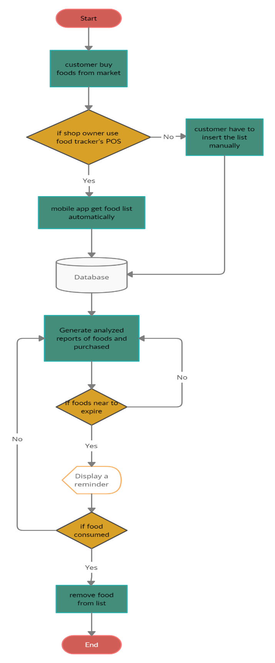

Figure 1. Food tracker Flowchart

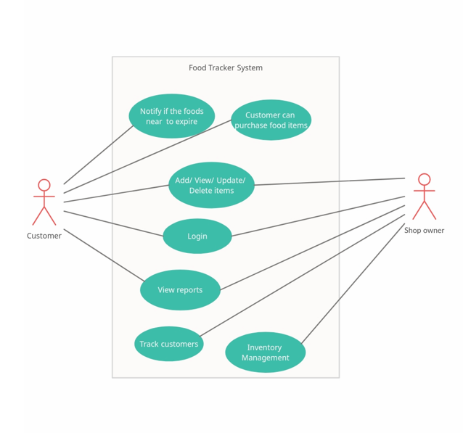

Food Tracker System UML use case Diagram

Figure 2. Food Tracker's use case diagram

Food Tracker Database Diagram

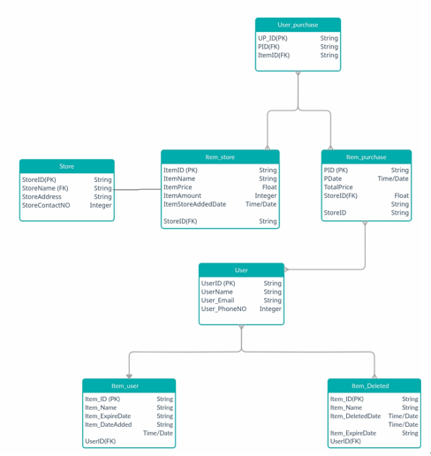

Figure 3. Food Tracker's Database Diagram

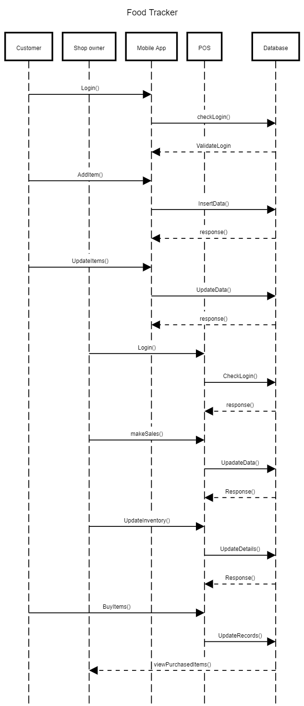

Figure 4. Food Tracker's Sequence Diagram

# Task undertaken and outcomes

|  |  |  |  |
| --- | --- | --- | --- |
| **Task ID** | **Task undertaken** | **outcomes** | **percentage** |
| 1 | Android mobile application with basic login and registration | Completed | 100% |
| 2 | OCR implementation on android application | Completed and fully functioning. but must add more features with User experience. | 80% |
| 3 | Manual Data insertion and data edit for the mobile application | Completed | 100% |
| 4 | Real time database connection of the android application & POS | Firebase database used in the Android app and POS | 60% |
| 5 | POS system with basic sales and inventory management functions | Developed some User Interfaces, but not fully functioning | 30% |
| 6 | OCR implementation for POS system | Identified the API’s and Dataset, not implemented yet. | 20% |
| 7 | Data syncing on both system | Android data syncing correctly. | 50% |
| 8 | Analysed reports for both application | Not yet designed or developed (TODO) | 0% |

Table 1. Task undertaken and outcomes

# Products produced and product quality

In here let’s discuss the implementation between the start of the project which included in the interim 1 document and implementation have done so far. Since the last report mobile application now having full functioning methods. Which including user login with user email and password, login using with user’s google account, users can use their Facebook credentials for the mobile application login. Other than that mobile application main function, the OCR technology is now working properly. Which the user can capture the item’s details including name and expire date.

## 6.1 Login

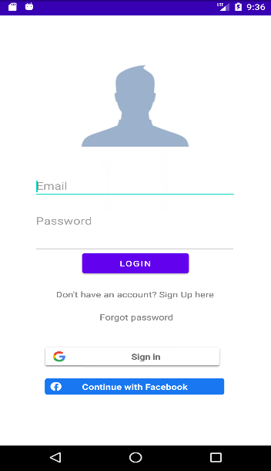

Previously (in interim 1) the login of the mobile has not implemented. Only had designed the user interface in the Adobe XD. In that design also only having the basic user login, which not including various options to mobile application user to choose.

When to login to this application user can choose several options. Such as they can create their own account, they can use their own Gmail address or else they can login to application using users Facebook. And once the user login to the application they do not need to a login every time when opening the application.

Figure 5. Login User Interface

## 6.2 User Signup

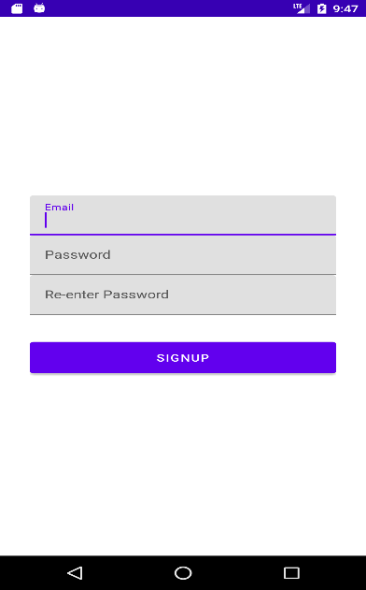

In the Signup users only have to enter their valid email and password. For the extra validation, users have to re-enter their password to confirm password is memorisable.

After creating the account users does not need to login again to the account.it automatically login and redirect to home page of the application

Figure 6. Registration User Interface

## 6.3 Forgot Password

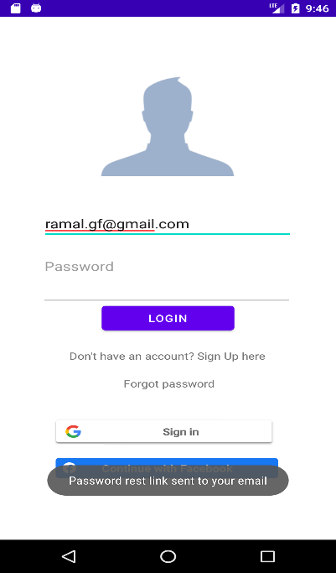

For the users who does not remember their password of their created account; users can simply enter their email address and tap the “**Forgot password**” option. When user done that their will be email will send to user email address to reset their account’s password. Which the user can reset password, without wasting time and could done in veery easy steps.

After the password is reset, user have to login to the application again. But still user can access their previous account records.

Figure 7. Forgot Password

## 6.4 Main menu

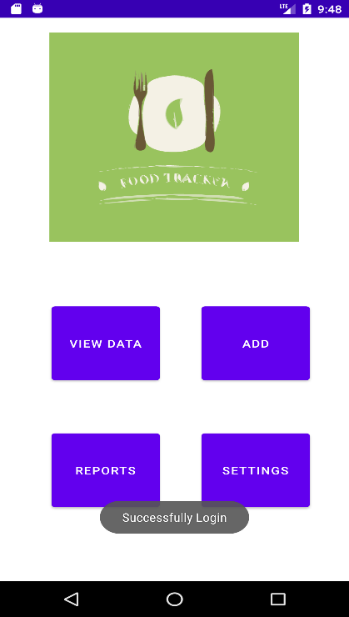

This is the main menu of the Food Tracker android application. It contains the all the features that the customer can use. On the top, it has “Check products” function. It will be used to checked purchased products and the product’s expire dates. In that function customer get and chance to update or edit data of their products. After that function there have a function called “Add Product”. Which is used to giving access to the user for add food items manually. It will using optical character recognition method to capture and automatically add to the list. Other than that, customers can enter the values manually.

In the “Remove Product” function, customer get ability to remove the expired or consumed products from the list. So, it has to be done manually or it can be change according to the other way. After that it has “Reports”. Which is showing the analysed reports of the purchased and consumed items likewise. “Setting” is the last function that available in the Food Tracker application. Form the setting users can customize their notification settings according to their preferences.

Figure 8. Main Menu Interface after the login to application

## 6.5 Add Items

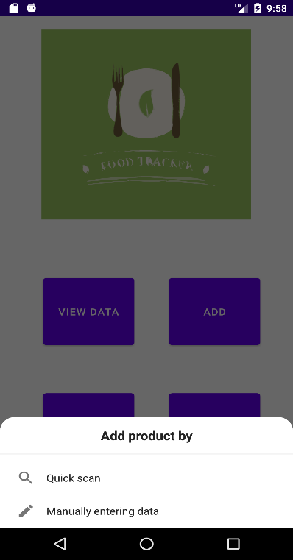

Figure 9. Add item pop-up message

Users can add their food items which are bought from the shops in this add data function. It is basically divided into 2 parts which can be define as Manual data insertion and Optical Character Recognition method. So, if the user selects the add data button it will popup a confirmation message that asking the ways of adding data. In that message user can select either OCR method or the manually adding method.

### OCR Method

Once the user selects the OCR methods to insert items data, they can add items by using their mobile device camera and capture the items name and item’s expire date respectively. It will automatically capture the and analyse the data and with the user’s confirmation it will be added to the mobile application database.

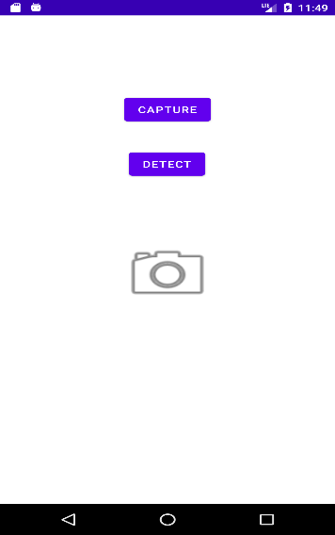

For the now instance it only having very simple user interface. And also, it can only identify the expire date and still not combined with main add item functions.

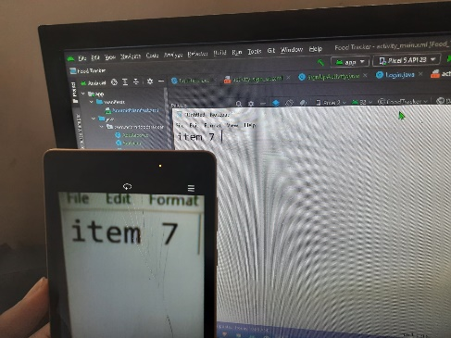

Figure 10. OCR main user interface

Figure 11. Capturing the data from the camera

For the example here I get the real scenario of getting capture for the OCR. And it is not capturing the handwriting, because of that user willing to add the item form OCR should not be written in the list. And here I still develop for the capture one picture and analyse, it can be hard to used for the users. So in the further development it can be a live recording the item list. For simple explanation it is will be like user have to open the camera and focus on to item name or item barcode to capture item name and user have to focus the camera to item expire date section. Then it will automatically capture those relevant data.

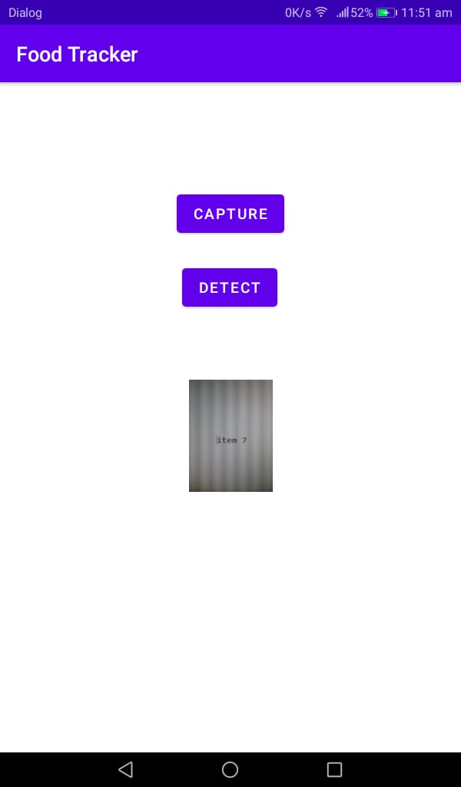

Other wise in this moment users have to capture the item name and expire date respectively. If it further breakdown first of all user have to click capture button and capture the item name or the item expired date. Then the user can see what is picture they have been captured.

Figure 12. confirming captured image

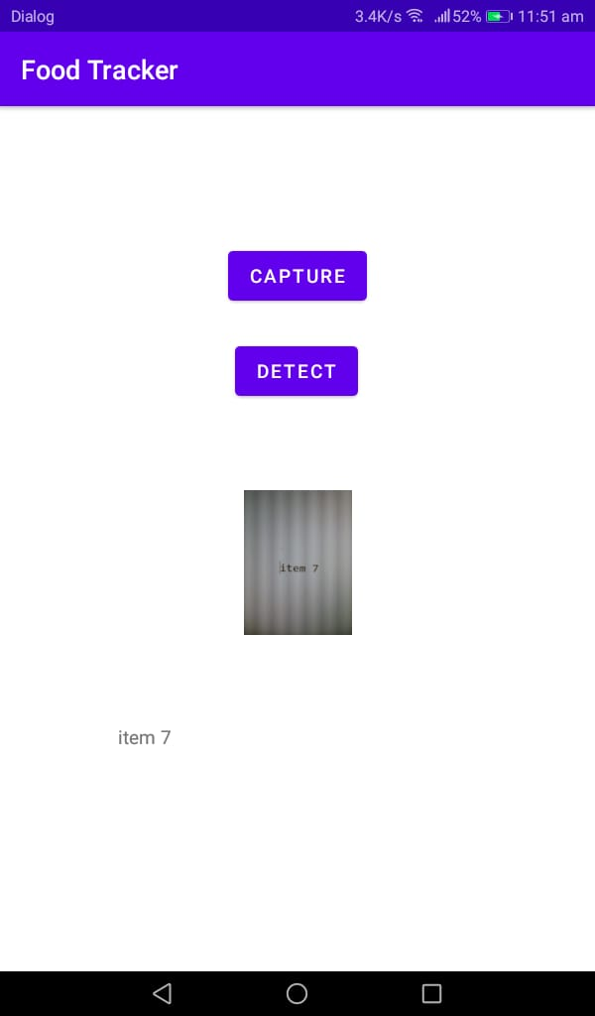

After user confirm the picture that they have been inserted is correct, they need to tap or click the “DETECT” button. Once they click that button OCR method will analyse and show the result of what the application has detect and analysed captured from the user entered image.

Figure 13. OCR result showing

### Manual Method

If the user selects manual method of data insertion from the main menu popup message, it will redirect to this interface. Which the users can insert their items data directly with keyboard input. User can simply add item name and its expired date. Once the data added, the items on his list will show down below

And if the user wants to edit the data that entered or captures, there is a button down the list called “Edit” under the list. It will redirect to the interface where the users can edit or delete their data.

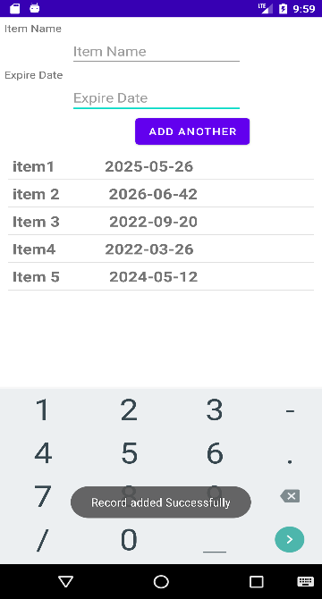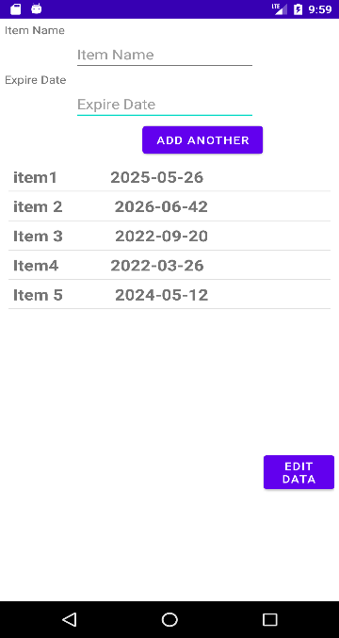

Figure 14. Add item confirmation messages

Figure 15. Add item user interface

## 6.6 View Items

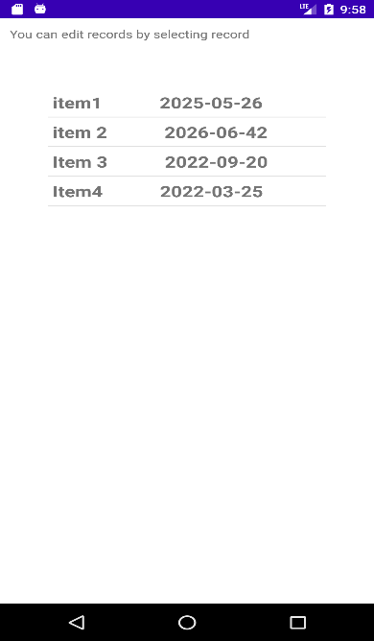

Figure 16. View Item user interface

In here it shows all the items and its expired date that currently on the items list.

If the user wants to change their data, can select the item that they want to update and it automatically shows in the interface that user can update their details in easy way.

## 6.7 Edit item

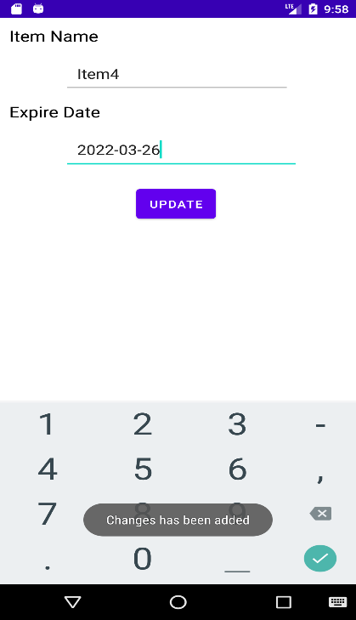

Once the user wants to edit items details, that request can fulfil in this user interface. For this instance, it only having update function. But with the further development delete item function will also add to this method.

# Test Case

## 7.1 Data Insertion using OCR in mobile application

|  |  |  |  |  |  |  |
| --- | --- | --- | --- | --- | --- | --- |
| **Test Case Name** | **Test case Step** | **Action** | **Test Data** | **Expected Result** | **Test Result** | **Note** |
| Test App | 1 | Open App | - | App Opened | App Opened | Success |
| Test App | 2 | Grant Permissions | - | Permission Granted | Permission Granted | Success |
| Test App | 3 | - | - | Camera Opened | Camera Opened | Success |

|  |  |  |  |  |  |  |
| --- | --- | --- | --- | --- | --- | --- |
| **Test Case Name** | **Test Case Step** | **Action** | **Test Data** | **Expected Result** | **Test Result** | **Note** |
| Test OCR | 1 | Hover over printed text | Item 7 | Item 7 | Item 7 | Success |
| Test OCR | 2 | Hover over written text | Item 7 | Item 7 | TTEM 7 | Fail |

# Risks that have materialized and your responses, changes to the risk list

|  |  |  |
| --- | --- | --- |
| **ID** | **Risk** | **Response** |
| 1 | Used to develop POS system as a web system | I decided to change the language to Java because it will be safe and user friendly. |
| 2 | Analysed reports on both android and POS system | Have to refer some tutorial on creating the reports in both development environment |
| 3 | POS system’s OCR implementation | Have to use some 3rd party API |
| 4 | Time | Working with daily basis to reduce the pressure about this project |
| 5 | Unfamiliar codes | Refer tutorials on each code |
| 6 | Bugs/Issues | Refer online materials and fix them |

Table 2. Risk and Responses

# Schedule

## 9.1 Project Plan

|  |  |  |  |
| --- | --- | --- | --- |
| **ID** | **Stage** | **Deadline** | **Product/Deliverables/Outcome** |
| 1 | initiation | 11/17 | PID |
| 2 | Investigation and requirements | 12/03 | Analysis of existing business process.  Requirement document.  Evaluation of possible development technologies. |
| 3 | High level design | 12/07 | Design documents (Architecture, DB schema, modular decomposition, GUI style guide, etc) |
| 4 | Increment 1 | 01/22 | Sub-system providing customer facing functionality |
| 5 | Increment 2 | 02/10 | Sub-system providing communication between the internal function units |
| 6 | Increment 3 | 02/15 | POS system implementation |
| 7 | System and user acceptance testing | 03/15 | Final system/solution |
| 8 | Assemble and complete final report | 04/10 | PRCO303 Report |

Table 3. Project Schedule

# Resources

* **Android Studio** (version 2020.3)

As for this project solution, it is mainly targeted to use by the any of the customers, who brought foods. So, when commonly most people are using android operating system-based devices, I have to create this solution’s mobile application according to those people choice. Therefore, this mobile application will develop in Android. For that Android studio IDE is the better choice for the developing this mobile application. Not only that android studio having many different and unique features for the android application development. Which is including customizable android simulators, easy access for the different android libraries, etc.

* **Apache NetBeans**

For the development of the point of sales system for the shop owners, it is easy to use operating system independence language. Therefore, Java is the best and easy way to handle this situation. Other than that, there are lots of libraries are available for java language, which is very Important to create this project solution.

* **Adobe XD**

Adobe XD is giving better figure when creating the user interface and easy to understand the how the user experience when using this project. I have selected this software for when creating the user interface of the mobile application and the point of sales system.

* **Machine Learning kit on Android**

When developing the optical character recognition method for customers mobile application, I have to use this library to implement to that method.

# Learning undertaken and Required

* Android Machine Learning libraries

Google developer community have a better introduction to the beginner about the Machine Learning kits. This will be helpful for when implementing the optical character recognition method on android application

* Tesseract API

Which is machine learning library or the API that is use for character recognition. There are some courses and code explanation available in online.

* Firebase Database

Database system that used in android mobile application. Google developer community and YouTube have some valuable explanation of this technology.

# Appendices

## References

* Google Developers. 2022. *Text Recognition | ML Kit | Google Developers*. [online] Available at: <https://developers.google.com/ml-kit/vision/text-recognition> [Accessed 22 January 2022].
* GeeksforGeeks. 2022. *Tesseract OCR with Java with Examples - GeeksforGeeks*. [online] Available at: <https://www.geeksforgeeks.org/tesseract-ocr-with-java-with-examples/> [Accessed 22 January 2022].

## Proposal

**Food tracker**

**Proposer**

J. P. R. Chamuditha Jayaweera - 10707234

**Proposed supervisor**

Mr. Iman Ashly

**Problem statement**

One of main problem all around the world is food wastage. There are two main kind of food waste. Food loss and food waste. From that two categories food loss is a comparatively bigger than the food waste. Food loss can be defined as any edible food that goes uneaten at any stage. In addition to food’s that uneaten in homes and stores, or the in the fields, foods spoils in transportation and all other food that doesn’t make it to store.

When talk about the amount of food wastage only in America has about 68 percent or about 42.8 million tons of wasted food, generated in 2018 and it ended up landfills or combustion facilities. Moreover, food waste that is not handled properly or reclaimed properly through the composting can have many negative environment consequences. As an example, landfill gas from anaerobic digestion of organic matter is a major source of the greenhouse gas methane. And un-reclaimed phosphorus in food waste, leads further phosphate mining. Moreover, reducing food wastage in all a part of the food system is an important part of the reducing the environmental impact of agriculture, by reducing the total amount of water, land use and other resources.

However, for many people in the world food waste has become a habit. Buying more food than we need at markets, letting fruits and vegetables spoil at home or taking larger portions than we can eat. Sometimes we forgot what we bought and just leave in the refrigerator or in the pantry. And after the expiration date we dump those foods or products without consuming. If we are good enough to manage those, we can reduce wastages by ourselves. But with the busy lifestyle it is normal things forgot the products and foods stored in home. For that kind of instance, we can simply use a mobile application to get remind if our food going to expire.

**Project description**

As mentioned in the above most of the peoples living in these days are spending very busy lifestyle. They may be busy in the work as well as technology. Rather than the few years back, after the pandemic situation peoples are get closer to the new technology. They love to use new technology or new things other than the manual or old systems. So, for the food wastage we can simply use a mobile application. From that mobile application, user get notifications if their food that bought from the market are near to getting expire.

And not only that, but user can also see different kind of recipes from the food items that they have bought from market. And nowadays people are very much concerning about their foods. Even they limit foods to prevent from various diseases. So, from this application might help to choose wisely to select foods according to the calories. When user check out the application from mobile, he/she can see number of calories include in each food items. Another specialty of this mobile application is user does not need to spend time to add food items one by one to this application. This application will get all the data that user purchased from the market.

So, this is not only for the user, but this also connect with a shop. Normally supermarket have a specific database to store manufacture date, expire date, price, calorie amount of the product. When the customer or user buy the foods from that supermarket mobile application automatically get the details what he/she brought and save that information like wise. This project can save time, wastage, money, and the environment.

**Project keywords**

Foods, Tracking, Mobile, Application, healthy

**Requirements**

* APIs for the food identifications
* Hosting servers

**Finance**

Not available

**External organizations**

Not available

**Other staff**

Not available

## PID

* 1. **Introduction**

**1.1 About Us**

Food wastage is a very huge problem, and it is not just only in a one country, it is affected all around the world. There are two main types of food waste as food loss and food waste. Food loss can define as any food that is discarded, incinerated, or otherwise disposed of along the food supply chain from harvest but excluding the retail level and is not used for any other productive use, such as animal feed or seed. Food waste can be referred as food that discarded at the level of retailers, food service and providers and consumers. As a general food consumer, we can’t help to stop food loss, but we can help to stop to food wastage. We can use day to day technology devices for stop this wastage.

**1.2 Introduction**

Food is thing that if one can get and other cannot afford it. Some can get more food and other can’t have much. Most of the peoples are busy these days. They are not much care about the things other than themselves. So, people have forgot that little things that can be a huge problem as an example we can take food waste. Which can define as foods that discarded by the consumers. If we simply go through that we can refer food waste as, the foods or foods product that buy from market and discard or throw away without consume. That is not much big problem for the one single human, but it will be uncontrollable environmental matter which cause by the environment pollution. How can be that environment pollutions occur? It is caused by food wastages that we throw away fills with greenhouse gas also known as methene. And un-reclaimed phosphorus in the food leads further mining. This food waste can also be a reason for environmental effect on agriculture, by reducing the total amount of water, land, and other resources.

In the other hand food is basic need of a life. But there are countries which are suffer from the famine. One country’s people waste foods and some other country’s peoples are dying for not having enough foods for consumption. one in nine people do not have enough food to take, that’s 793 million people who are undernourished. if we manage it correctly, we can fair to all the people living around the world. When we are talking about the food wastage in numbers one third of all food produced is lost or wasted. Around 1.3 billion tonnes of food, costing the global economy close to $940 billion each year. The 10% of the greenhouse gases are come from the foods that is produced, but not eaten. If food waste was a country, it would be the third biggest greenhouse gas emitter after the United State of America and China. In those greenhouse gases which mainly contain methane, are 28x stronger than carbon dioxide.

As mentioned above we can help to protect our environment that cause a huge global problem by following simple rules. In the last two years’ time people are changed with pandemic situation and move on with new technologies. So how can be this revolution can change the food wastage. Most people are busy with their day-to-day life activities, work or education, family, or various activities. but the people never refuse to go through their mobile phones, laptop or any smart devices. Even they have a very busy lifestyle they spend at least small amount of time with their mobiles. Some people used smart devices just for browsing social media or internet and some of them are used to do their daily work. So, without wasting a time on social media how we can referral people to save the earth. We could get the biggest chance having the pandemic, which is now the people love to be using the technology other than the manual or old systems or methods.

Nowadays most of the shops/supermarkets are introduced their own brand mobile applications. Or they are selling products through the online food ordering companies and online web sites. So, there are lots or customers are using these facilities through their smart devices. and for those people can use mobile application which remainder if the customer’s bought foods are going to expire. And, by without wasting those foods, can use as an ingredient to make different foods. In these days, people are more care about foods calories and the energy amount contained in the foods. So, from this application user or customer will be able to get information of the calorie in their foods. They can get different food recipe according to the foods, that they owned according to the energy’s foods have. When these mobile application users are raising the amount of foods, that can be save without waste also raise. Personally, mobile application can be an advantage in many ways. It can help user’s health, financial, and creativity. From this mobile application can focus the users to make different kinds of food according to the different recipes. It can help to enhance the user’s creativity. Otherwise, when we manage our foods without wasting and get maximum use of foods it saves the money.

* 1. **Business Case**

**2.1 Business Need**

In these days, people are busier with different matters. They do not have much care about the food they bought from the supermarket or shops or their expire dates. But people are more familiar with mobile phones rather than the few years ago. So, from the mobile application user get notifications whenever the foods getting near to expire. Not only notification but also user can view different types of recipes from the foods that are going to expire and the foods which are bought and stored. And in this mobile application shows the number of calories that certain food has. by that, user can get clear picture for the foods that he should get or the foods that he should change.

**2.1.1 Underlaying Problem**

The expire date of each food are different, and users can not spend their time to create the list of foods that he/she bought on market.

**2.2 Business Objectives**

To save the foods without wasting and bring new recipes from foods customer have and

* Reduced the amount of money that waste from food waste.
* Remind the users if the foods that are not consumed, are going to expire
* Acknowledge the users how much calories they consumption.
* To bring healthier food recipes.
* Manage the foods items accordingly.

**3. Project Objectives**

1. To analyze the foods or the products which are wasting with weather conditions.

1. To analyze and figure it out how the shops/supermarkets databases save the information’s of the products.
2. To analyze potential development technologies and deployment solutions
3. To implement the new mobile application and POS software for the shops or supermarket.
4. To provide real-time mobile application and POS for the customers and the shop owners with a correct data.

**Chapter 4: Initial Scope**

1. Business processes (and their shortcomings) will be identified by observation, and (possibly) documented using UML activity diagrams.
2. The proposed system will allow
   1. Shop owners to release their bill as an electronic generated bill.
   2. Customers to view on purchased list on the mobile application.
   3. Customers will get food item list automatically after shop owners confirm.
   4. Customer can add manually if he/she bought foods or products from the shops which is not using this system POS software.
   5. Customers to get notifications or remainder about food or product expiration.
   6. Customers able to see recipe according to the foods he/she has bought.
   7. Generate recipe with the foods before if the one or more items are going to expire.
   8. Customers to remove products.
3. User requirements will be elicited using interviews, observation, and the development of user stories. User requirements will be expressed primarily in text.
4. The more complex user requirements will be elaborated into detailed system requirements either using text, use case descriptions and/or a use case realization. A class diagram will be produced.
5. **Method of Approach**

Software development will employ an incremental approach, with several increments focussing upon

1. Shop owners POS (Point of sales) system which maintain product details like expire date, manufacture date, and amount of energy or calories.
2. Customers mobile application that contains the main functions in the described project.
3. Interconnection between POS and mobile application with real-time and without data failure.
4. High quality user interface and user experience should include into both POS and mobile application.

Possible technologies are PHP/JavaScript/CSS/MySQL for the POS system and Android/Firebase for the mobile application, for hosting purpose have to use third party hosting sites. although a full evaluation will take place during the project.

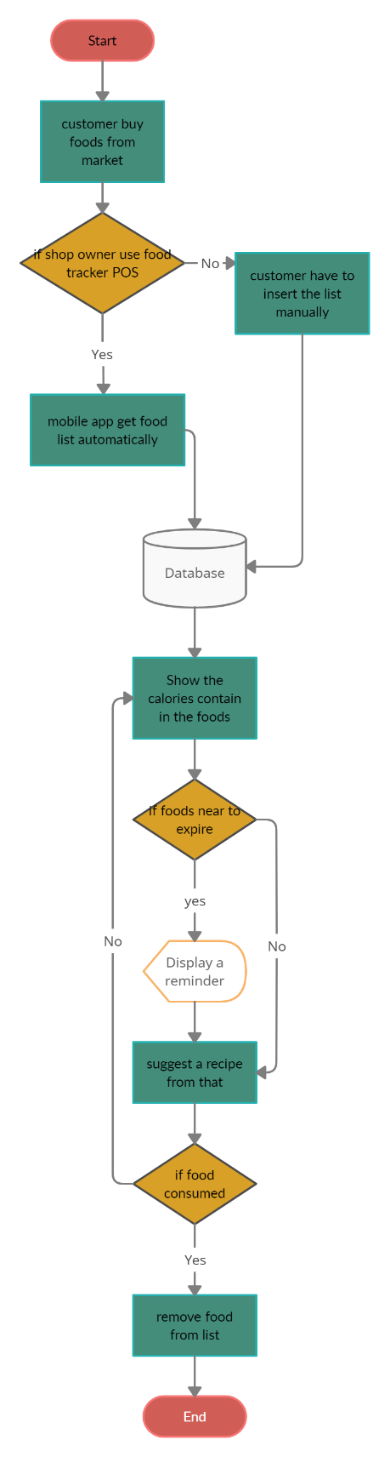

Figure 1. Flow chart for the **Food Tracker**

1. **Project Plan**

**6.1 Control Plan**

First have start with project proposal and then need to analyse and should create Project Initialisation Document (PID). Then must meet supervisor weekly and module leaders to get advice if there should be having to get change the project scope. With those of advice have to keep the logbook or diary for the changes that done to proposed system. Have to create documentation and video captures of the projects in every milestone. In other hand have to take risk and deploy the proposed system. Also, should create documentations which is mentioned in the module guide. Finally, must create final report for the created program and finalize the final software product.

**6.2 Communication plan**

In addition to ad-hoc supervisor meetings as necessary, planned review/feedback meetings will be held at the end of each stage in order to discuss the end-Stage report, the next Stage plan, and to review any technical deliverables produced during the stage. Feedback meetings will also be held following the submission of the two Interim reports. Any additional communication ( via email or additional meetings) will occur as needed.

Table 1. Stage 1 Plan

Table 2. Stage 2 Plan

1. **Initial Risk List**

What can go wrong and what management strategies are you adopting now to deal with these.

Table 3. Initial Risk List

1. **Initial Quality Plan**

What quality checks are you going to apply to your products, and when?

Table 4. Quality Plan

## Meeting minutes

